Book Recommendation

<https://grouplens.org/datasets/book-crossing/>

* Not sure if this can be considered as a large dataset
* Site also has some other projects that you guys can take a look

<https://grouplens.org/about/projects>

# **Integrate AWS DynamoDB table with machine learning for sentiment analysis**

[Integrate your Amazon DynamoDB table with machine learning for sentiment analysis | AWS Database Blog](https://aws.amazon.com/blogs/database/integrate-your-amazon-dynamodb-table-with-machine-learning-for-sentiment-analysis/)

https://aws.amazon.com/blogs/machine-learning/detect-sentiment-from-customer-reviews-using-amazon-comprehend/

**Project Summary:**  Creates a product review summary based on the sentiment, and keeps updates in optimized format for future ad hoc queries and analytics

**Workflow:** the solution uses a serveless event-driven architecture with automated steps

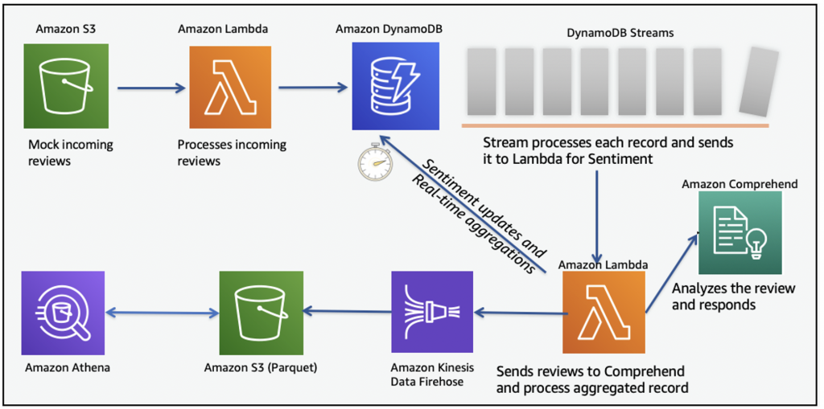

Pros:

* Hands-on code available, a good tutorial
* Published recently
* AWS experience is useful

Cons:

* This topic is frequently appeared in previous example (but this method is new)
* Need to learn several AWS services, time consuming

Building Job Portal with twitter streaming data

<https://www.ijrte.org/wp-content/uploads/papers/v8i2S8/B10090882S819.pdf>

* **Goal B:** (a) what kind of topic you plan to do, (b) what you plan to cover in your tutorial (including what to demonstrate, if applicable), (c) where resources you plan to draw upon (books, videos, PPTs, articles etc - so that the instructor can also evaluate the feasibility and interestingness). (d) what use case you plan to use, including links to data sources.

<https://medium.com/ankercloud-engineering/sentiment-analysis-on-chatbot-conversations-understanding-human-computer-interaction-f01b10e57714>

**Goal B:** (a) what kind of topic(chat box data to predict customer churn/ sentiment analysis/customer preferences) you plan to do, (b) what you plan to cover in your tutorial (including what to demonstrate, if applicable), (c) where resources you plan to draw upon (books, videos, PPTs, articles etc - so that the instructor can also evaluate the feasibility and interestingness). (d) what use case you plan to use, including links to data sources.

1. We plan to use Sentiment analysis on chatbot conversations/customer reviews to analyse customer preferences and analyse these preferences to predict and possibly reduce customer churn. The main aim of the project is to describe the application of sentiment analysis using machine learning on aws.92% of consumers say that they will stop purchasing from a company after 3 poor customer service experiences.

[Sentiment analysis on chatbot conversations (Understanding human-computer interaction)](https://medium.com/ankercloud-engineering/sentiment-analysis-on-chatbot-conversations-understanding-human-computer-interaction-f01b10e57714)

<https://aws.amazon.com/blogs/machine-learning/detect-sentiment-from-customer-reviews-using-amazon-comprehend/>

(d) To demonstrate the technology, we plan on using Amazon review data in the pet supply category from 2018 and use sentiment analysis to find reviews that are associated with low ratings, which would likely lead to customer churn in those who purchase pet supplies. Vendors could then improve their products or customer service approaches accordingly. The technology could then be further applied to more product categories or even data beyond the retail industry, such as customer support or chat bot conversation records.

To test streaming functionality: <https://aws.amazon.com/blogs/big-data/test-your-streaming-data-solution-with-the-new-amazon-kinesis-data-generator/>

